The Emission of Light From Charged Particles

© Declan Traill 9/2/2006

The following diagram illustrates how light waves are emitted from an oscillating charged particle (in this case an electron), as a string of loops of vector potential, and how these loops of vector potential can be thought of as being electric and magnetic fields.

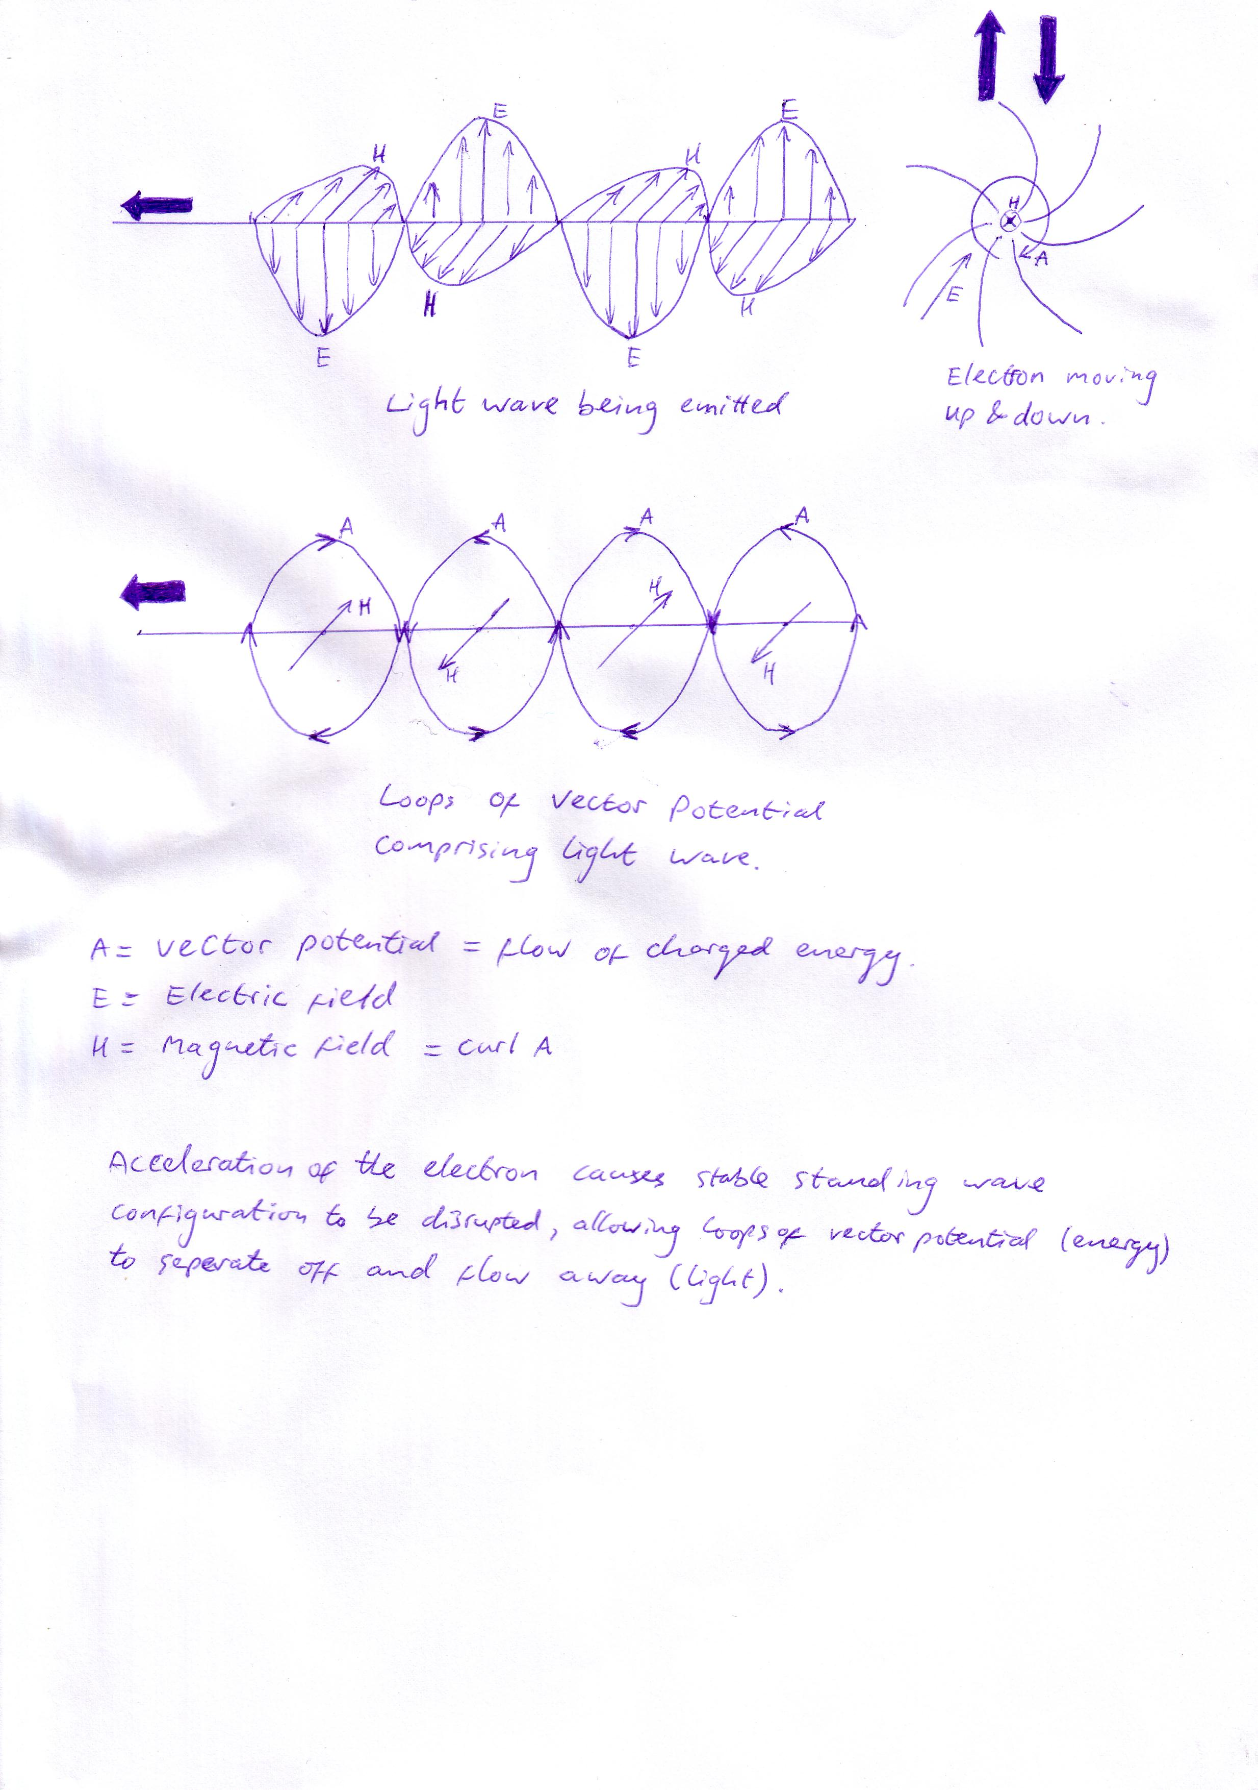

References:

Towards a Unified Field Theory
The Mechanics Of Charged Particles

